BRD for Pre-Physical App
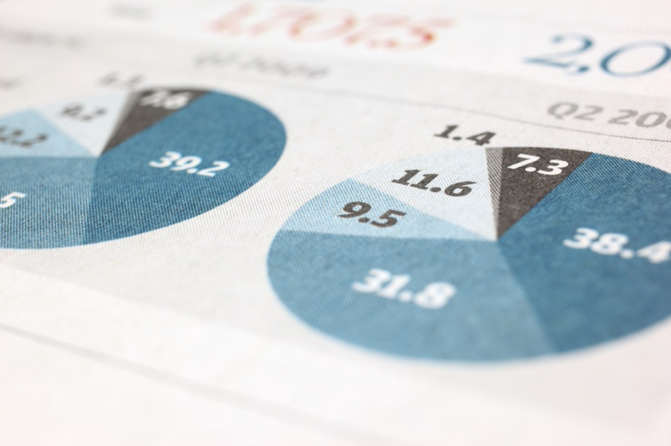
BRD for Pre-Physical App
[Document subtitle]
Author | Date | Version
Eliezer Mashihov | 12/25/25 | 1.0

BRD Approval History:

Change & Approval Log

Rel. | Date | Comments | Preparer | Reviewer / Approver | Review/Approval Date￼ | Role
1.0 | Eliezer Mashihov |  |  |  |  | author

Table of Contents
1.1 Business Objective/Problem: 2
1.2 Data Sources: 4
1.3 Business logic for data Joins and report/dashboard design: 4
1.3.1 What are the filters for modeling or front-end 5
1.4 Business Terminology and Front-End Flow: 6
1.4.1 Visualisations on each page: 8
1.5 Security and User base: 19

Business Objective/Problem:
Currently, the pre-physical process is manual, where you must visually cross-reference CPoint data against the machine’s actual configuration. The current process is prone to human error due to the complexity of the Compatibility Matrix and the subtle differences in file structures and licenses. This might result in prolonging the cycle time of a tool, and pass it to the next stage with a configuration that was not properly checked.
We want to achieve:
- automate the lion’s share of visual, specification or software based checks.
- We want to enable the capability to validate the tool with minimal access to the tool itself.
- Reduce cycle time, if we cut the software validation duration by 50% per tool, we can enjoy this saved time for other utilities.
- Standardize the report for a clear audit of the tool’s state, what missions are PASSED and which missions are FAILED.
- Provide clean and functional GUI to perform the Pre Physical procedure with.

Who is the user for this application?{Elad}- every owner of Pre-physical activity, OI to FI HS
- Adi and Ben who perform the procedure.
- More?

What is the time gained by implementing this application? {Elad}- predicted 40% improvement of HS \ Pre-physical
According to Adi who practices this procedure proficiently, it can save around 30 minutes.

How often does this app will be used?
The procedure is happening on a daily basis, so this app will be in use for every day.

What are the KPIs or features that the user audience want in the app?
Open during working meeting
Save pre physical processes for future analysis (like time, etc)
What decisions making flow during pre-physical procedure?
Throughout the procedure many steps can cause a “break” – so that we can’t pass the procedure, but have to fix something. Open during working meeting

What do users want to include in their report?
[what?]

Data Sources:
- CPoint access to data of tool
- Connection to tool (full connection / virtual folder access)
- Compatibility matrix
- CFP Assistant access data
- Use Nexus data (Client 1, 2, Server)
- Use MCDB data
- Access FleegHub data to flag ‘running’
- ver.txt file on tool
- AcuShape version_new.txt on tool
- if rdm -> rdm_ver.txt on tool
- *.ktlic files on tool
- lmtool.txt or lmutl.txt data from tool – for diagnostics & email

Business logic for APP design:

BUSINESS TERMINOLOGY AND Front- End flow

Additional Features
-

Appendix:

Security and User base:

